**Earmark Template (EM)**

When funds are set aside for a specific purpose or project, they are known as “earmarked”. This prevents the funds from being spent in other areas, thereby maintaining healthy cash flow.

At Q1 we absorb the data from the stargate team at detail level. We validate the data and process it into Vena. At every quarter, major chunks involve taking a booking cut, processing writeback data and loading the inflation adjustments centrally for earmark module.

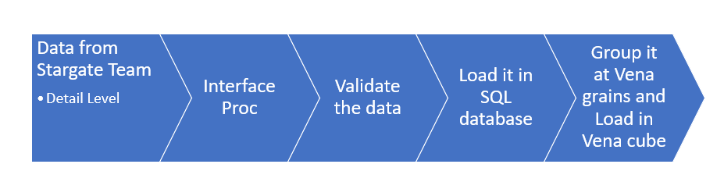

Figure . Earmark Module Data Ingestion Process at Q1

It further flows in the Analysis Template, Allocation modules, and reporting framework.